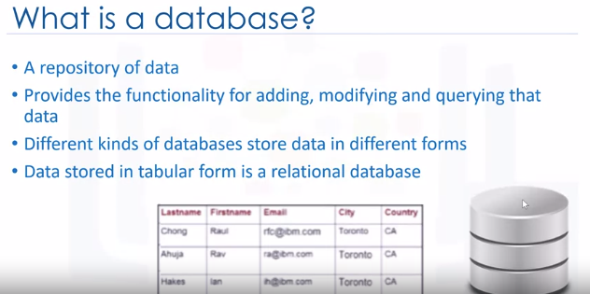

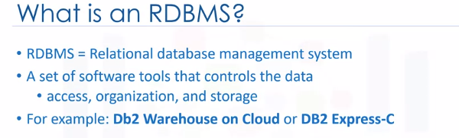

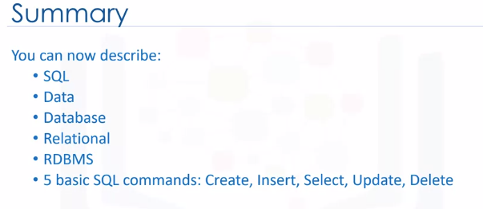

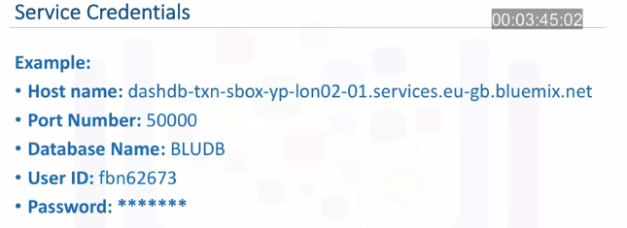

Three types of databases – relational databases, hierarchal, NOSQL

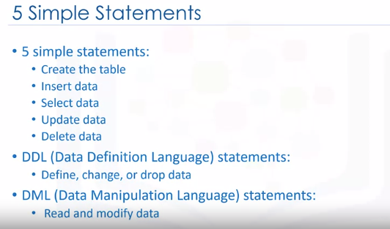

Create table statement

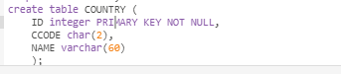

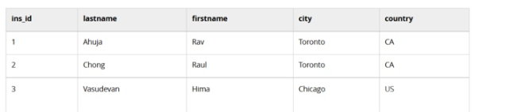

Drop table Example: - drop table COUNTRY;

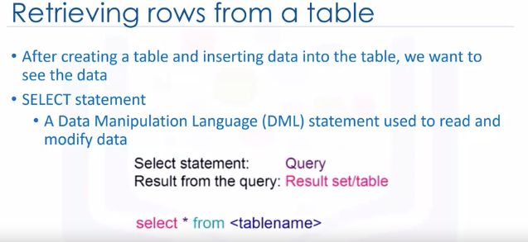

**select ID, NAME from COUNTRY where ID < 5 ;**

**SQL – COUNT, DISTINCT, LIMIT**

**Entity – attributes**

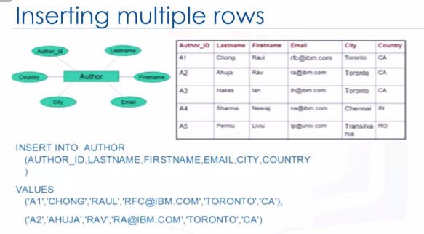

**Update statement**

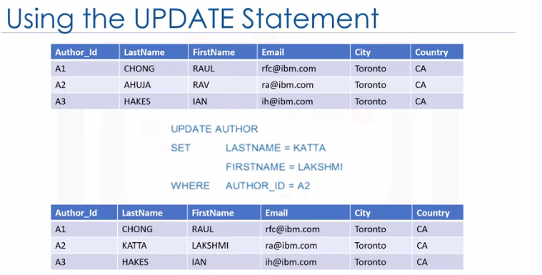

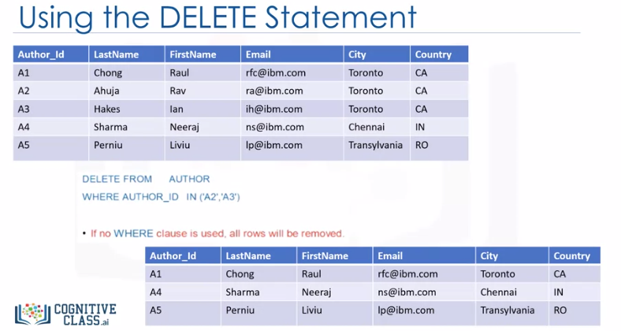

**EXAMPLE**

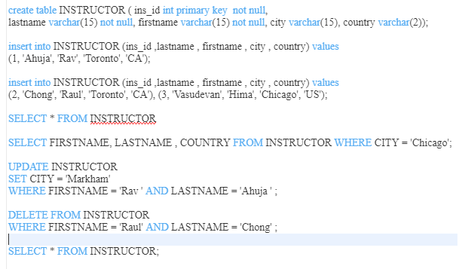

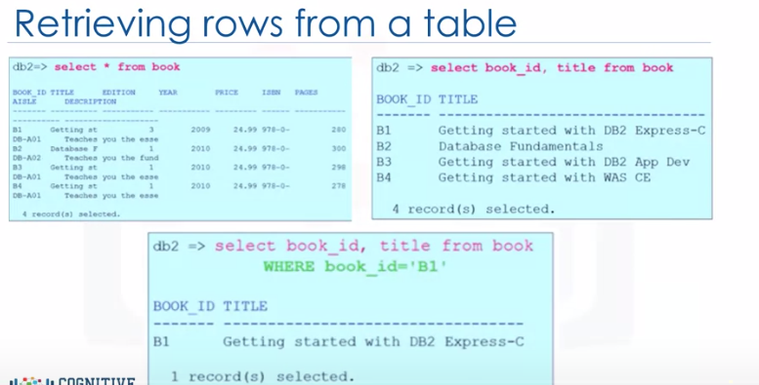

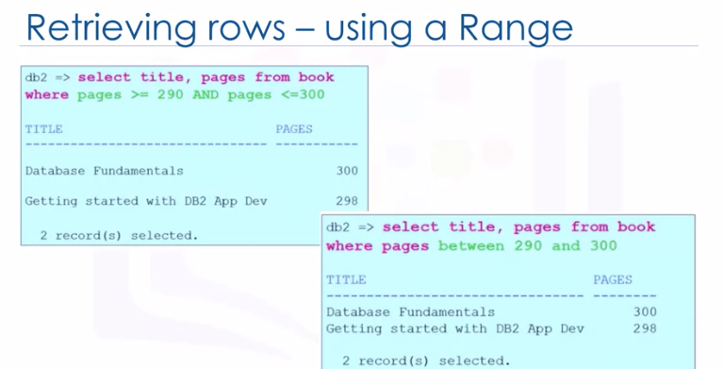

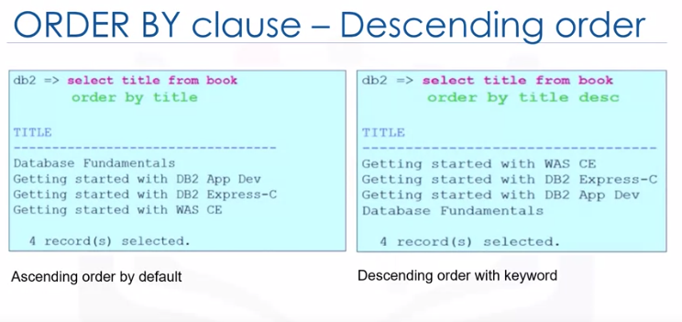

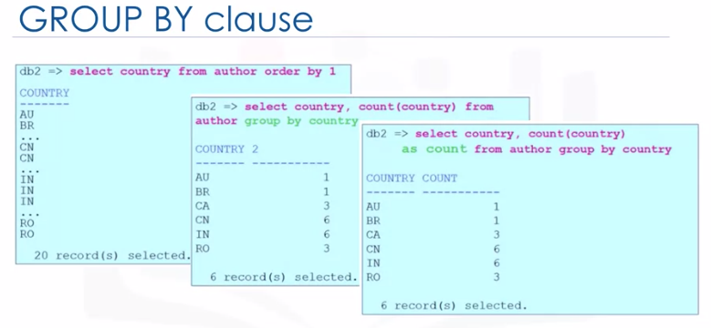

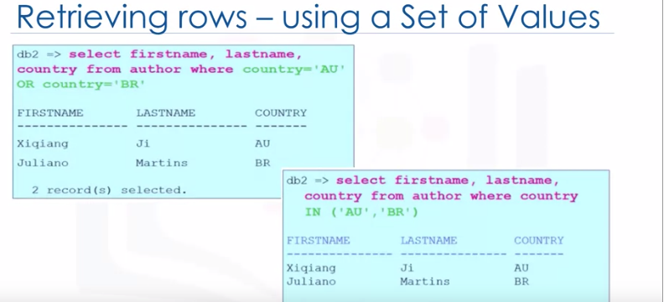

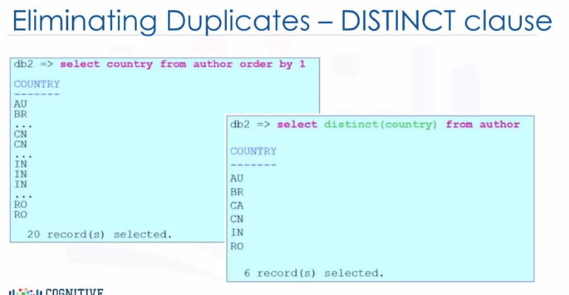

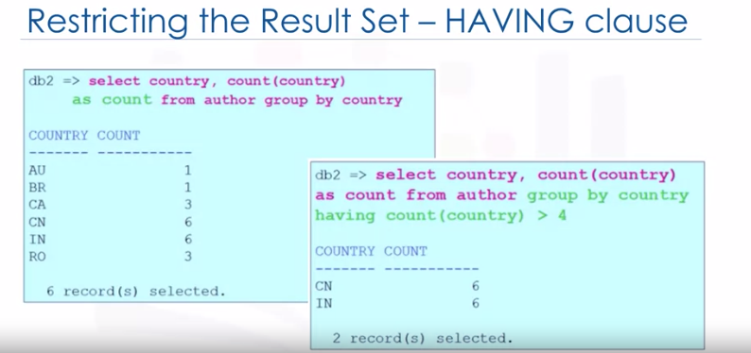

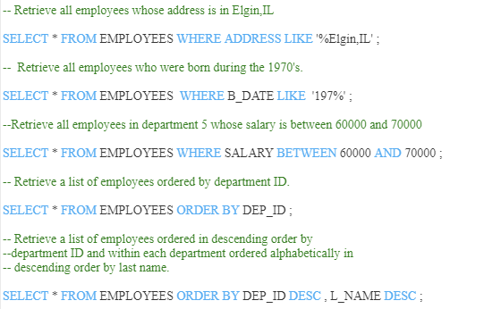

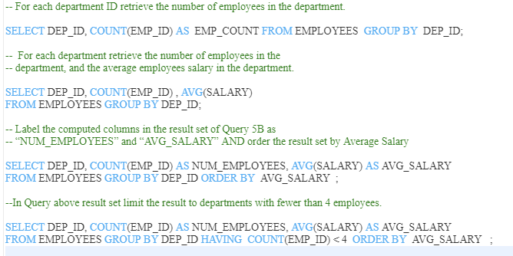

**SELECT DEP_ID, COUNT(EMP_ID) AS NUM_EMPLOYEES,**

**AVG(SALARY) AS AVG_SALARY**

**FROM EMPLOYEES GROUP BY DEP_ID**

**HAVING COUNT(EMP_ID) < 4**

**ORDER BY AVG_SALARY ;**

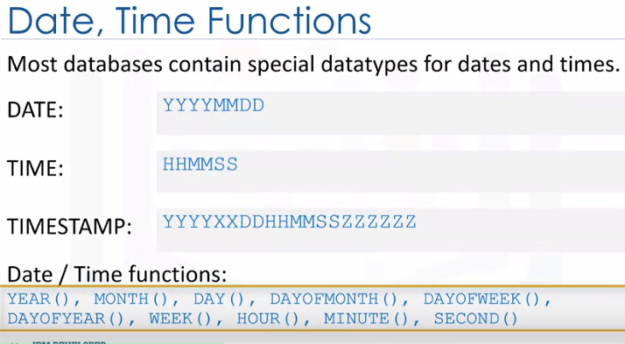

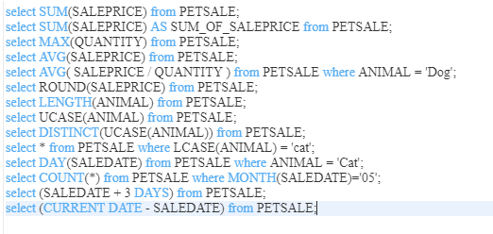

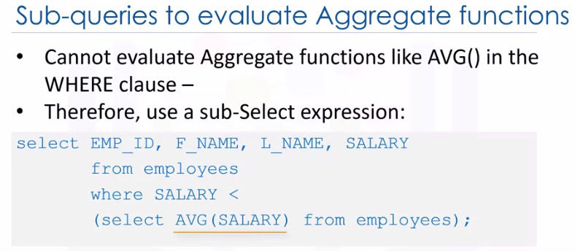

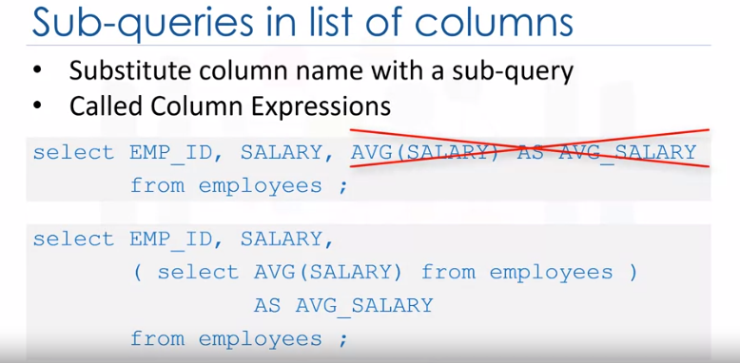

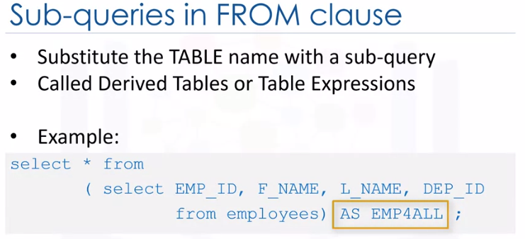

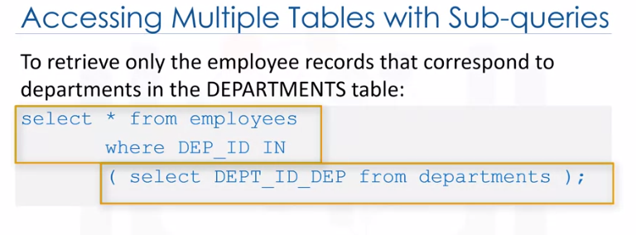

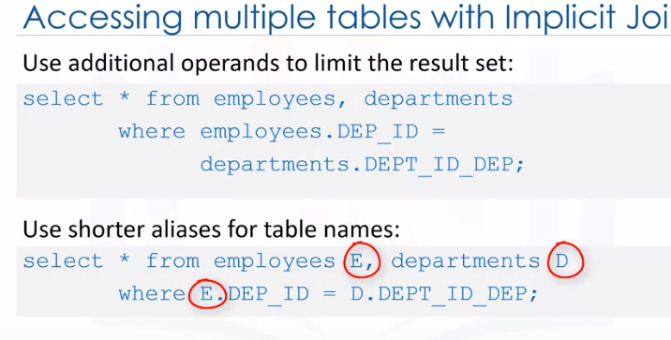

**SELECT E.EMP_ID ,E.SALARY, D.DEP_NAME FROM EMPLOYEES E, DEPARTMENTS D**

**WHERE E.DEP_ID = D.DEPT_ID_DEP AND SALARY > (SELECT AVG(SALARY) FROM EMPLOYEES);**

**Example of Multiple Table & Sub Query**

**Select employee id , salary and dep_name from emp & dep table**

**Where employee table_dep_id = dep table_dep_id and filter with avg salary subquery**

**SELECT E.EMP_ID ,E.SALARY, D.DEP_NAME FROM**

**EMPLOYEES E, DEPARTMENTS D**

**WHERE E.DEP_ID = D.DEPT_ID_DEP**

**AND SALARY > (SELECT AVG(SALARY) FROM EMPLOYEES);**

**select F_NAME , DEP_NAME FROM EMPLOYEES , DEPARTMENTS WHERE DEP_ID = DEPT_ID_DEP ;**

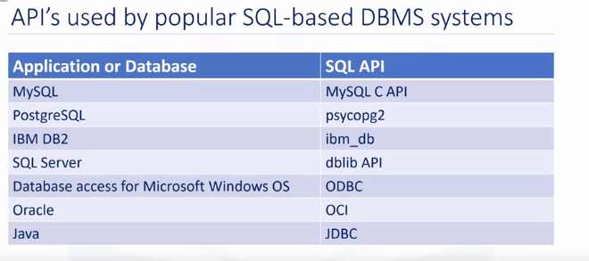

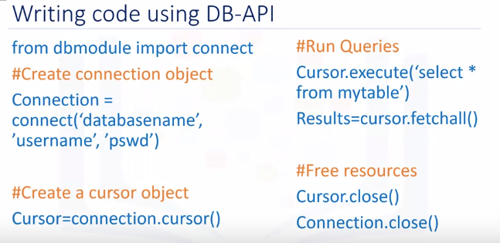

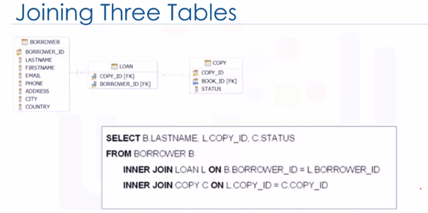

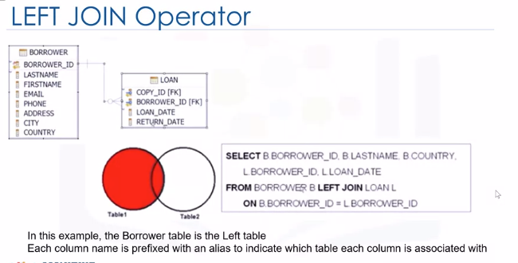

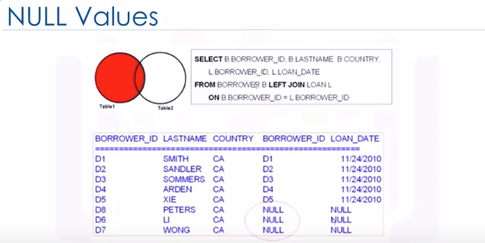

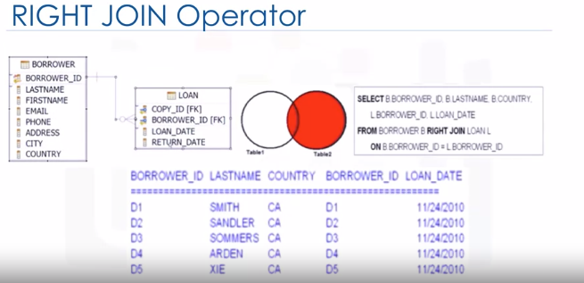

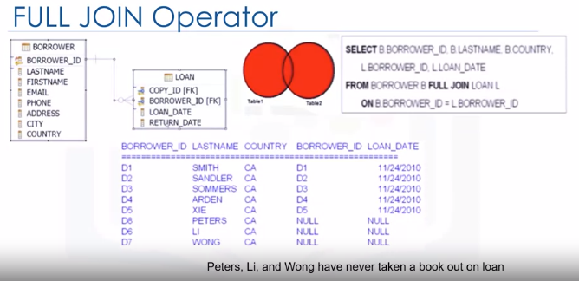

**Access Database Tables**

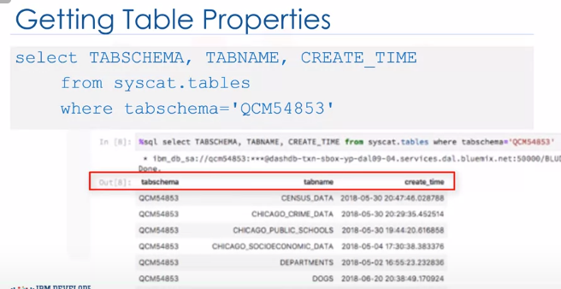

**Access Database Table - Columns**

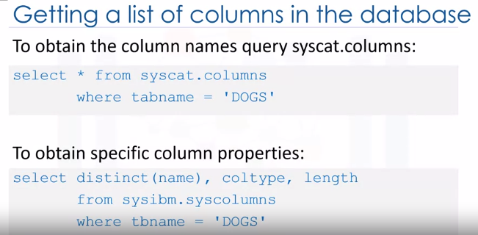

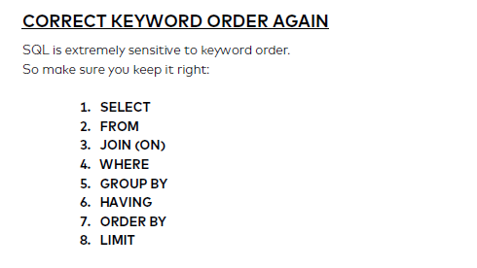

SQL first checks which data table we will work with. Then it checks the filters. After that it groups the data. Finally it gets the data – and if necessary, sorts it and prints only the first X lines.

Data transformation – Feature engineering in SQL

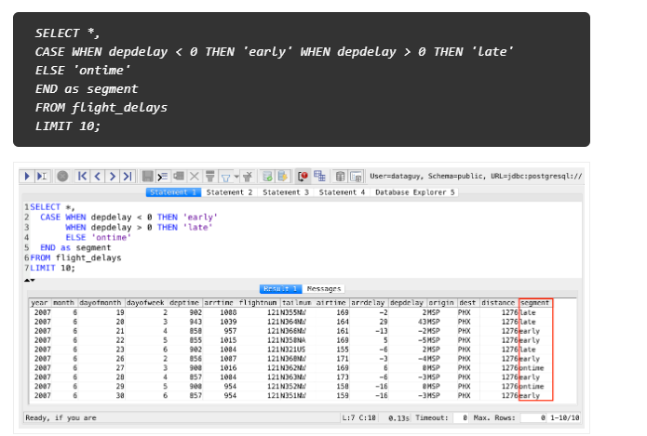

SELECT COUNT(*),

CASE WHEN depdelay < 0 THEN 'early'

WHEN depdelay > 0 THEN 'late'

ELSE 'ontime'

END as segment

FROM flight_delays

GROUP BY segment

LIMIT 10;

some quick and dirty data cleaning/transformation

* change all the values from ‘M’ to ‘Male’ and from ‘F’ to ‘Female’ in a table
* turn a continuous value into a categorical value (like we did in the above example).